Home Page // Order page // Payment Page // Inventory page // Status Page

· Home Page
Take order button (àMadto sa order Page)

May sidebar for inventory and status page(maintain ta ni ang sidebar? From homepage to payment page?)

· Order Page
(w/ editable checklist/cart (Or pwede man ubrahon ta nga check2 shts na lang per item nga pwede ka add or minus button para wala na cart2))

May button to proceed to payment

· Payment Page
Ma show orders, total, pira received nga money

Then du receipt2 lang nga may orders, total, money received, then change. (Ipakita lang sa customer, if want nila pwede nga take picture lang)
(Ma save sa sales ang receipt shts2 para sure)

Then proceed to order page naman

· Inventory Page
Ari automatic ma update ya sales and inventory based sa orders na

May another shts naman (page or sum) para ma edit ang sales and inventory if needed, or if mag restock
Makita ang sales(order shts, jan ang details and ang receipt)

· Status Page
Status of orders (Eisenhower type shi)
Order served, paid
Order not served, not paid
Order served, not paid

Or amu ka ja(Name, serve, payment lang(?))
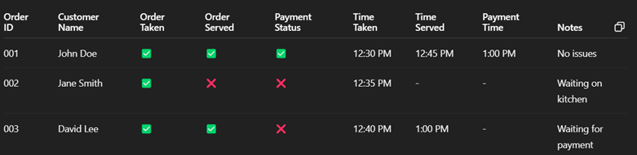
(Automatic ma edit ang status after order placed, then ma change lang ang inventory if order is served na)

